1) Database Preparation (SQL)

During SQL view creation the first views did contain several data columns because i was not having the oppurtunity to talk to stakeholders and actually evolve needed data. Reading through the tasks from the Project doc did not help that much because i could not grasp the whole picture at that time, at first i did include all the date columns like shipping, required or even the freight column.
After working with the first measures and starting to create visuals i did finaly see which columns were not needed and then refined the views.
Since the renaming of only the supplier_id was asked by the tasks within the SQL part and later technical columns were asked to be renamed within PowerBI i did not rename further columns.
Personaly i would rather create view ready tables within the DB and then create views where i would rename the names of the columns to fit the needs within the dashboard and make the appearance within PowerBI fit a common foundation agrreed upon bz the teams working on it.

2) Data Modelling (PowerBI)

I did load the desired tables employees and shippers even though they did contain data that should not be imported to PowerBI from my understanding, since those tables have not been mentioned within the SQL part i supposed it is due to simplify the project and focus on more important actions.
I still did decide to hide several columns as birthdays, addresses and other personal data.
Currencies and region data formating have been adjusted to all corresponding columns.
At first all ID's have been set to summarize as "Count(Distinct)", which i then did change back to "Don't summarize" since i encountered an issue within the drill-through task and i did not need that option anyways. Unit Price, Quanitity are "summable".
Technical names have been renamed using CamelCase and whitespaces as delimmter.
Star schema was created with one:many cardinality from dimensions to fact, plus a Calender table of type Date and using Short Date to not Display day names within the Drill-through table. On top sorted by months to fit the order within the line chart.
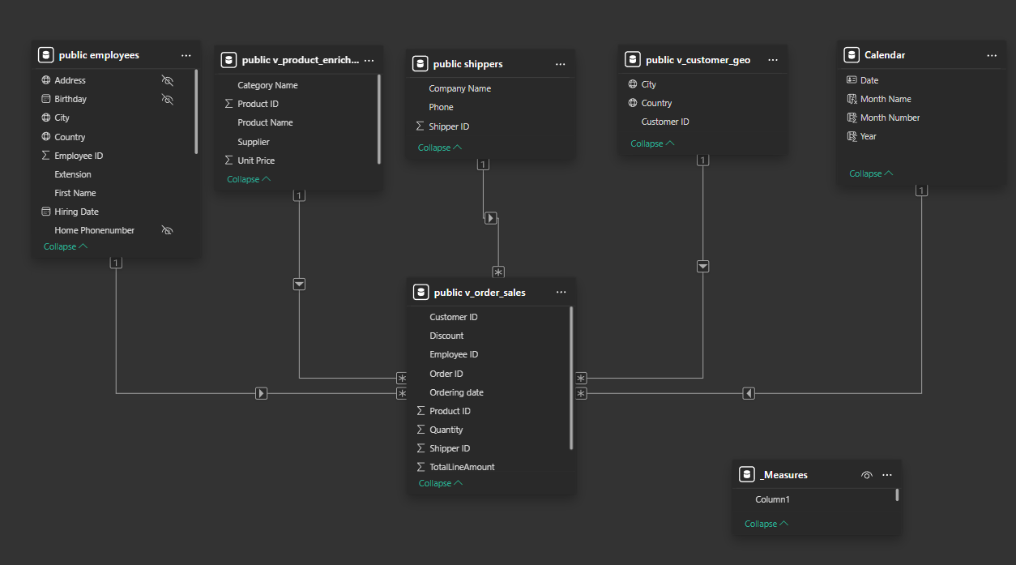
3 ) Calculations (DAX

- SUM over in SQL precalcualted value
- Count Distinct values explicitly
- Divide using measures but handle any error with 0 as default value.

- SUM over Quantity

- Use function to calc revenue to date
- CALCULATE function with SAMEPERIODASLASTYEAR
- Difference total revenue, revenue previous year by revenue last year
- Row by Row calculation of TotalLine Amount of Filtered values where discount is 0
Then use that "Total Revenue without Discount" to calculate percentage of revenue gereated without discounted
Yes this could have been performed within SQL, the question is, does the tablesize of our dataset within PowerBI expand the performance capabilities of our machine, is creating a new column with null values within the DB(as a flag) a better option performance wise. Summing over row by row was not performed by me so far plus storing inside a variable and then using that within a measure was something new to perform by me, so i picked that approach. Filtering using FILTER instead of IF conditions looked neat too.

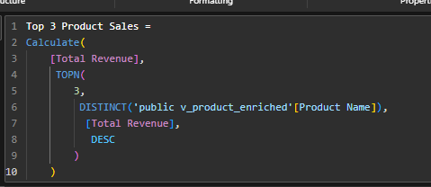
Adjusting the look of the measures to fit SQL formatting and ease visualization.
So first of all TOPN returns a list of the Top 3 Products regarding their share of the Total Revenue descending. Calculate then runs Total Revenue but only on the filtered (return values of TOPN) products.

4) Visualization (Dashboard)

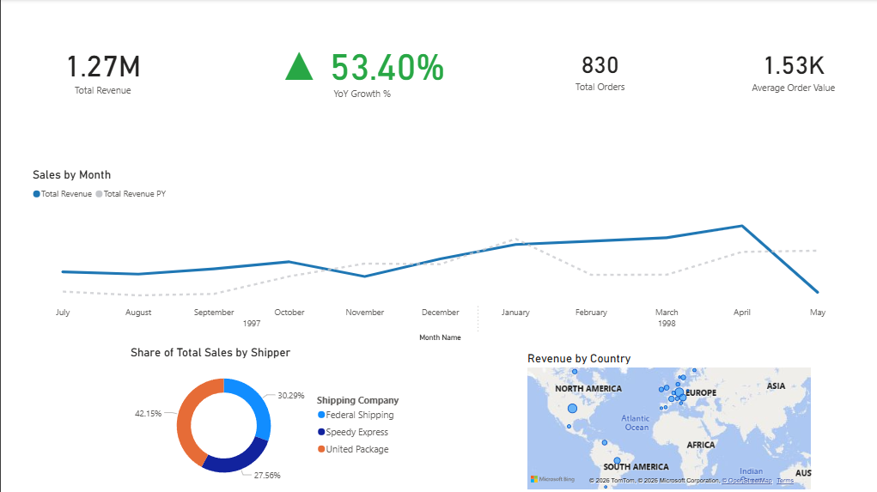

Following the Z-schema the KPI's are ordered from left to right matching the order from the project description, where the size of the fonts are differing. Total Orders and Average Order Value are the smallest values displayed since they are not that important, The Total Revenue is slightly bigger, Big number -> good! Finally the YoY Growth % is the biggest number since it shows a trend and is of most importance to an executive. It is additionaly colored using formatted conditioning (green positive, red negative) with an additional triangle as a symbol to assure colorblind oberservers can benefit too.
The line chart by month contains the total revenue and the revenue of the previous year, values have been filtered to only display values where both measures actually have existing values. The Total Revenue uses a thicker line with according blue and the PY Revenue is dotted and grey. Hovering over the lines will highlight a the values with grey background to focus on the highlight and stand out abit.
Bottom left we have the donut that displays the share of the total sales by shippers. Any Filters ore interactions for this visual have been set off. Finally we have the bubble map displaying revenue by country.

At first all visuals could and would interact with one another but then it was pretty messy to choose the right options, look for how things would interact with one another and i decided that someone spending seconds on that report won't use it if clicking can mess it up and you would have to actually "learn" how to use it to afterwards find needed information.

Interactions decided to use:

The linechart does interact with the YoY Growth % and the map, showing shares of sales by countries and bubble size. I made the Line chart interact with the Growth because it is THE most shiny value, the interaction with the map is not visualy draging the focus away from the growth to much, so if there was more then 5 seconds, en executive could use it if interested. But it is not overwhelming or distracting.

The donut does not interact with anything at all, this is a base value showing share of total sales, filtering by other visuals would lead to distorted values not assembling 100% totals and the invested amount of time to make this work was not worth the time. Regarding on feedback by users this could be handled.

The map does not interact with the Line chart because it would Irritate the user once the linechart starts shifting, strechting compressing and what not, the focus is on how and what works which would make the Dashboard way to complicated and people with little time would never use it. At least i personally did not benefit from it without investing more time to get used to how it works.

BUT if one did catch interest from using the points within the linecharts, the bubbles within the map are clickable and will filter all KPI's.

I was intending to make use of a reset button, so that once filters applied an obvious button would resett everything, but due to PowerBI needing to remind me that i have to enter my email and what not, i decided to not work through that problem and let my CEO pay for my Pro Licence and give me the needed tools in case he/she needs more functionality.
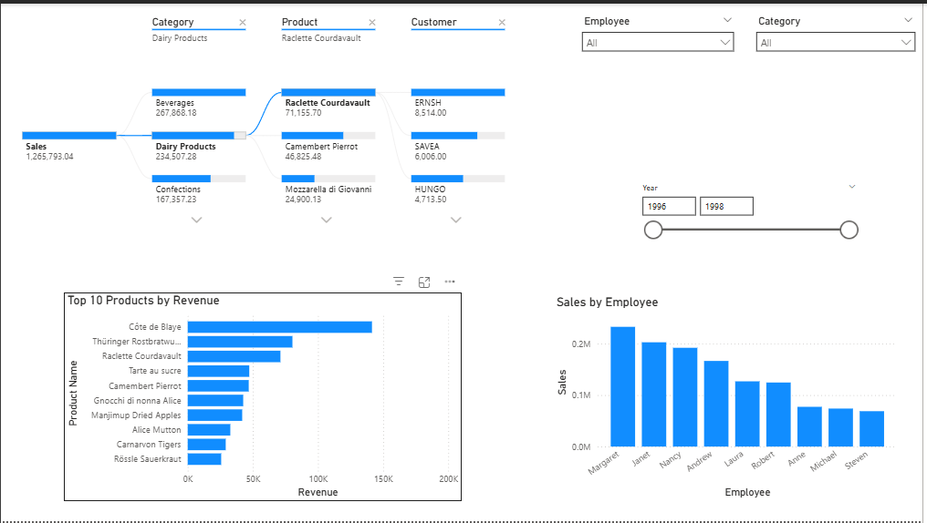
The most heavy analytical visual with drill-through option was placed top left, most time can be invested here. It did get more space then the other visuals to make up for the amount of time spent working on it. To the right are the slicers that can be used to adjust filters as needed. The Employee and Category slicer are drop downs, tiles did look very cool but they did dake away too much space plus this is for analysts, no need for shiny toys.
The drop downs dont cover up the year slicer that's why it is moved bit further down, the drop down slicers are arranged to take same space and be alligned to each other, the year slicer fitting in the middle of them.
The bar/columns charts are pretty simple and will change according to options set within the slicers. Focusing on the top left one can follow the bar/column charts out of the corner of the eye.
Hovering over any value will highlight the values for deeper analysis if desired.

Interactions are restricted to slicers, no need to click into visuals and make all values filter each other. I did find that to extend the level of complication without much benefit. Handling slicers should be enough. Feedback with users would actually help in decision making.

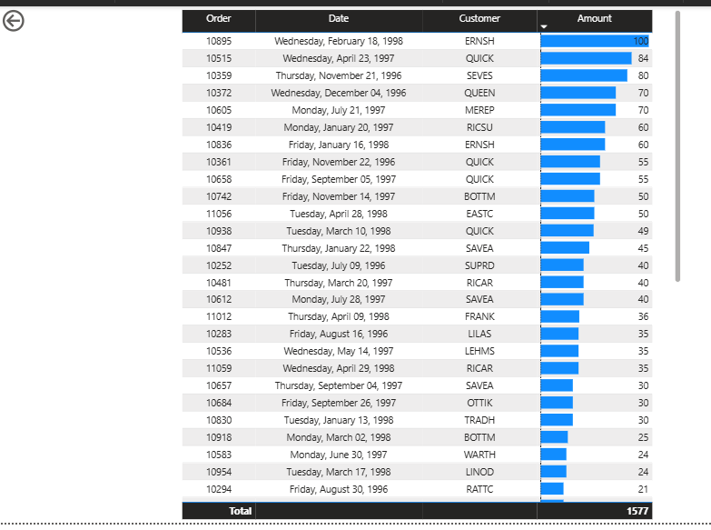
Drilling throught the Decompostion tree a detailed table is displayed showing, order, dates, customers and amount. Amounts are formatted to use bars for fast orientation.Rows are sorted by amount.
As a service desk analyst the first years in my company have been pretty rough regarding the abreviations and learning them to know which company actualy had which ID. So let's help our fellow analysts and create a tooltip that will display the full name of the company, since we don't want the full name within the table.(takes up alot space and drags focus from important values plus it looks messy)

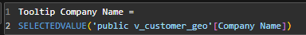
Create a meassure that will get the company name. Connect the tooltip page to the according visualization of the drill-through table. Fields of tooltip -> Company Name from v_customer_geo
Then customer ID in the tooltip value field.
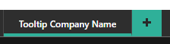
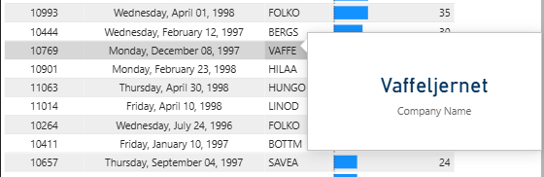

Now hovering over the abreviated customernames displays the full name of the company.

